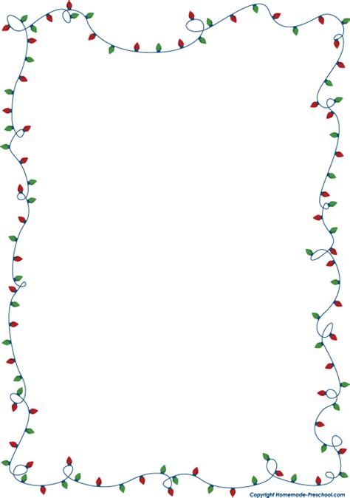
Santa’s Gift Shop

Season’s Greetings!
Santa’s gift shop is back! Dec 7th-Dec 9th

- PAC sets up a “store” in the school with items ranging from $1.00-$30.00
- If your child participates, they will need a “shopping list” completed. Please find shopping lists on our PAC page links section or see attached.
- Please complete the form with your child and specify $$ amounts to be spent on each recipient.
- They will shop at Santa’s gift shop in their class allotted time. Class schedules will be provided soon.
- Gifts will be wrapped and ready for Christmas

PLEASE NOTE: Children will only be permitted to shop if they have their list and money with them.

PAC receives a percentage of the proceeds to help fund PAC initiatives and you will be shopping local!!

Thank you so much to our sponsors:
- Back country
- Dunvegan Gardens
- The Hair Bin
- Canadian Tire
- Zoo Foods
Currently, we are seeking donations of gift bags and gift tags. These can be left at the office.

If you are willing to volunteer or would like more information, please email Jennkstanley@me.com or message our PAC page.

Thank you for your support,
Happy Holidays

